Network Technology Project (IE3070)

Year 3, Semester 2

Project Proposal Report

(NTP/2023/25)

**Aqua Sync-Tech**

**Smart Water Meter for Billing and**

**Monitoring with Mobile Application**

Submitted to

Sri Lanka Institute of Information Technology

In partial fulfilment of the requirements for the

Bachelor of Science Special Honors Degree in Information Technology Specialized in Computer systems and Network Engineering

**Aqua Sync-Tech**

**Smart Water Meter for Billing and Monitoring with Mobile Application**

|  |  |  |  |  |  |
| --- | --- | --- | --- | --- | --- |
|  | **STUDENT NAME** | **STUDENT NO** | **CONTACT NO** | **EMAIL ADDRESS** | **SIGNATURE** |
| 1 | Ashik M.A.M  (GROUP LEADER) | IT21478338 | 0771177207 | It21478338@my.sliit.lk |  |
| 2 | Manathunga M.D.T.L | IT21300196 | 0702763025 | It21300196@my.sliit.lk |  |
| 3 | Jayasinghe S.S | IT21366154 | 0764605086 | it21366154@my.sliit.lk |  |
| 4 | Sujath S.M | It21392108 | 0764118007 | It21392108@my.sliit.lk |  |

**Group Members**

Supervised by:

(*Supervisor’s Signature*)

…………………………..

*Name of the Supervisor*

Miss. Narmada Gamage

Date of Submission

**August 28, 2023**

**Declaration**

"I certify that no material previously presented for a degree or certification from any educational institution appears in this paper without appropriate citation. Furthermore, this document does not contain any content that has been previously published or written by someone else, to the best of my knowledge and belief, unless express acknowledgement is made in the text.

**Abstract**

Efficient water usage monitoring, Cost of water and conservation have become unstable now a days in Sri Lanka. This project proposes the development of "**Aqua sync,**" an Arduino-based device equipped with a water flow sensor, RTC Module and many other sensors aimed at revolutionizing water consumption tracking and historical billing records. By enabling users to gain accurate insights into their water usage habits anytime, Aqua sync promotes responsible water usage, timely billing cycles, and informed decision-making with a Mobile application also which is integrated with physical device. Currently, water monitoring systems have lacked the accuracy and accessibility required to encourage users to actively manage their water consumption. Aqua sync seeks to bridge this gap by providing real-time and precise water usage data through an intuitive LED display. This feature proves especially beneficial for users who are not comfortable with mobile applications or modern technologies. The primary objective of this project is to employ advanced technology to streamline processes, significantly reducing the labour and time needed for manual billing calculations. Aqua sync automates the generation of monthly water usage reports and bills, facilitating both customers and administrators in managing water consumption and billing matters efficiently. Furthermore, Aqua sync’s capabilities extend beyond billing. The system's technology aids in identifying potential leaks or anomalies in real time. This proactive feature allows users to take prompt actions, users can directly ON/OFF the water supply with the help of controlling sensor, thus minimizing water wastage and financial losses. The mobile application associated with Aqua sync also provides a geographical tracking feature, helping users locate their devices effortlessly. The Accurate Water Usage Monitoring with Aqua sync project aims to introduce a comprehensive solution that not only offers accurate water consumption monitoring and billing but also empowers users to adopt mindful water usage practices. By leveraging technology to automate processes and provide real-time insights, this project aligns with sustainable water management goals while addressing the challenges of water conservation in a rapidly changing world.

**Keywords:**

Water flow sensor, RTC Module, Water consumption tracking, Historical billing records, LED screen, Real-time data, Anomalies, Geographical tracking

**Table of Contents**

Chapter 1 1

1.1. Introduction 1

1.2. Research Gap 2

1.2.1. Gap Analysis Chart 3

1.3. Research Problem 4

1.4. Research Objective 5

1.5. Research Questions 6

Chapter 2 8

2.1. Background & Literature survey 8

Chapter 3 10

3.1. Methodology 10

3.2. Block Diagram 12

Chapter 4 13

4.1. Testing & Evolution. 13

4.2. Gantt chat 14

Chapter 5 15

5.1. Conclusion 15

References 16

Appendices 17

Personal & Facilities 17

Budget 18

**List of Figures**

[**Figure 1.1 Aqua Sync app interface** 2](https://mysliit-my.sharepoint.com/personal/it21478338_my_sliit_lk/Documents/NTP%20-%20Narmada%20Gamage/Proposal%20Document/Proposal%20Document%20-%20Aqua-Sync%20Tech.docx#_Toc144155381)

[**Figure 2.1 Block diagram of project 01** 8](https://mysliit-my.sharepoint.com/personal/it21478338_my_sliit_lk/Documents/NTP%20-%20Narmada%20Gamage/Proposal%20Document/Proposal%20Document%20-%20Aqua-Sync%20Tech.docx#_Toc144155382)

[**Figure 3.2 Block diagram of project 02** 9](https://mysliit-my.sharepoint.com/personal/it21478338_my_sliit_lk/Documents/NTP%20-%20Narmada%20Gamage/Proposal%20Document/Proposal%20Document%20-%20Aqua-Sync%20Tech.docx#_Toc144155383)

# Chapter 1

## Introduction

This is an automated IOT based water metering system with an LCD display. Named “**Aqua Sync-Tech”**, which seeks to revolutionize water management. The system has water flow sensor-equipped embedded Arduino-based device to precisely quantify water use in real-time. The gathered information is subsequently transferred to a real-time database that is hosted in the cloud, making it easy to access and analyze. Varies kinds of sensors will be attached with the device to enhance the feature of the Aqua Sync-Tech project like detect water leakage, smart controlling system, residence location detection etc. The physical device connected with mobile application which we are developing for customers and management employees of Sri Lanka Water board.

There are two key parts.

1. **Physical Device** - The device is permanently attached to each home's water distribution start point.
2. **Web and mobile application** - Client users and admins who work for the Water Board use mobile applications.

With the help of LED Display, which is attached with the Device, People can monitor water consumption who are not familiar with mobile application and new technologies. The project's primary goal is to use advanced technology to reduce labors and labor time so that employees of the (Sri Lanka Water Board) won't have to travel physically to calculate and manually issue bills. Based on each user's consumption information, Aqua sync generates monthly water usage reports and bills for them. This result encourages opens, making it simpler for customers to keep track of their water costs and modify their usage habits as necessary. The Aqua sync application administrator will take care of all billing matters and generated. online bills will be sent to users monthly via the Mobile application.

The technology assists in locating potential leaks or anomalies, allowing for quick action, and

minimizing water loss by closing the water supply from the start point by the mobile application.

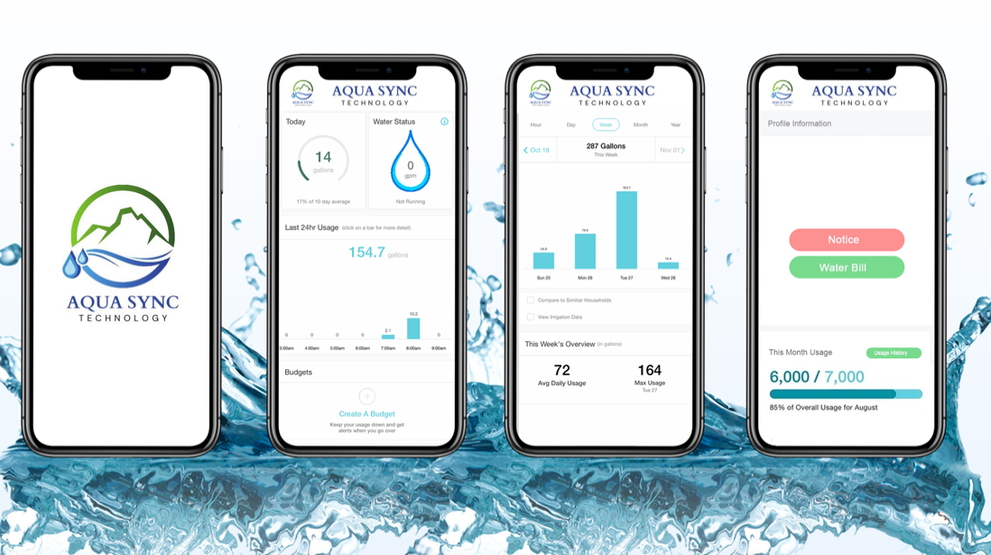

**Figure 1.1 Aqua Sync app interface**

## Research Gap

Lack of Real-Time Data Presentation means existing solutions do not offer an intuitive LED display for users to monitor their water consumption in real time. They use analog meter for water consumption. Incomplete Integration of Billing Many water monitoring systems do not efficiently maintain user friendly mobile application to integrate billing processes. Billing calculations might still rely on manual efforts, potentially leading to inaccuracies and delays. Another gap exists in a unified system that seamlessly combines real-time data display through LED and mobile application interfaces. Most solutions focus on individual aspects (monitoring, billing, leak detection) without offering an all-encompassing solution. Lack of Proactive Leak Detection, many existing systems do not actively detect leaks or anomalies in real time. Users may not receive prompt alerts about potential leaks, leading to water wastage and increased costs and people can’t take sudden actions from anywhere, our system offers a water supply ON/OFF control via mobile application.

Handling difficulties, In the in the current method, a water supply board member must locate the user's residence using his or her knowledge, but in our project's mobile application, an administrator user may quickly determine the user's residence location in case of an emergency, saving time and resources.

|  |  |  |  |  |  |
| --- | --- | --- | --- | --- | --- |
|  | | Project 01 [1] | Project 02 [2] | Project 03 [3] | Our Project |
| No | Features | Smart water meter for automatic meter reading | Measurement and Control of water flow using IOT | Smart Water Meters and Tap Leakage  Detection | Aqua Sync-Tech |
| 1 | Real time water Consumption Monitoring system with water flow Sensor | Tick with solid fill | Tick with solid fill | Tick with solid fill | Tick with solid fill |
| 2 | Digital Reading and monitoring feature for Users in home using LED Display | Close with solid fill | Tick with solid fill | Tick with solid fill | Tick with solid fill |
| 3 | Smart water controlling from anywhere anytime. | Close with solid fill | Close with solid fill | Close with solid fill | Tick with solid fill |
| 4 | Smart water controlling via Web Application with device network | Close with solid fill | Tick with solid fill | Tick with solid fill | Close with solid fill |
| 5 | Water leakage detection | Close with solid fill | Close with solid fill | Close with solid fill | Tick with solid fill |
| 6 | Alerting system for Users via Mobile Application | Close with solid fill | Close with solid fill | Tick with solid fill | Tick with solid fill |
| 7 | Automated billing generation system through mobile application | Close with solid fill | Close with solid fill | Tick with solid fill | Tick with solid fill |
| 8 | Water Quality management feature | Close with solid fill | Close with solid fill | Close with solid fill | Tick with solid fill |
| 9 | User location detection system using GPRS/GSM module | Close with solid fill | Close with solid fill | Close with solid fill | Tick with solid fill |
| 10 | Efficient user management for Water Board administrators using web interface | Close with solid fill | Close with solid fill | Close with solid fill | Tick with solid fill |
| 11 | Enabling the decision making with past consumption details | Tick with solid fill | Tick with solid fill | Tick with solid fill | Tick with solid fill |

### 1.2.1. Gap Analysis Chart

## 1.3. Research Problem

According to the research gap,

**Manual Billing Inefficiency**

* In Sri Lanka, Current water billing relies on manual readings, billings always calculated by a Sri Lanka Water board Employee who comes to collect the analog data’s monthly, it is causing delays and errors in the bill. This may cause results in customer dissatisfaction and challenges for billing accuracy.

**Lack of Consumption Awareness**

* Users in the residence (home) and old people who are not aware about the water unit and other things they only get it know when a water usage bill given by CWB in the end of month, so they don’t have the proper understanding about the water usage.

**Inefficient Resource Allocation**

* In the current system of water consumption monitoring and billing, the allocation of resources, both in terms of manpower and time, is highly inefficient. The reliance on manual processes for calculating billings based on customers' residence data consumes a substantial number of human resources.

**Environmental Impact**

* When an undetected leaks and anomalies contribute to wastage of a valuable resource. If we cannot detect that in a short period, it will be an Impacts in both revenue and environment negatively.

## Research Objective

**Main Objective**

Develop a user-friendly water usage monitoring device and mobile application for efficient billing, leak detection, Controlling and water conservation within 3 months to get the high marks in the project.

**Sub Objectives**

1. **Developing a water quality measuring mechanis to detect the water quality Using TDS Sensor**

To manage the water quality, we intend to use a water quality sensor called TDS to transmit real-time water quality metrics to a Esp8266 circuit and share them with a mobile application. And configure alerting system users to receive alerts when the water is unfit for daily use, such as drinking or cooking. So, from this sub objective our function “Water Quality management” could be achievable.

1. **Develop an algorithm to detect the water leakage and implement the sensor’s, Seonaid valve to control the water flow from Mobile application.**

In this sub-objective, we'll be developing an algorithm to detect water leaks and sending a detection alert to the system after that. Build The user's mobile application with control option manage the water supply with a Seonaid valve when a leak is detected, allowing the user to enable ON/OFF water supply at anytime, anywhere. So, from this sub objective our function “Water control management” could be achievable.

1. **Implement the coding for getting the water flow and do the mechanisms to display the water consumptions in physical device and Mobile application.**

In this sub-objective we will be getting the water flow rate with the help of water flow sensor attached with Physical device. That data used to calculate the water units in real-time, after the data received to cloud platform the data updated to mobile application and the received data directly connect with LED display attached with physical device in each user’s home. All the calculations will be configured in Arduino code. So, from this sub objective our function “Water unit management” could be achievable.

Water Usage can be calculated with the help of a simple formula which is: Q =V/t, [4]

Q = Flow rate (liters per minute or gallons per minute).

V = Volume of fluid (in liters or gallons).

T = Time (in seconds).

Note: Divide the flow rate in liters minute by 60 to determine how many liters have!

passed through the sensor in this 1 second interval, then multiply by 1000 to

Conversion to milliliters.

*Flow Milliliter’s = (flowrate / 60) * 1000.*

*Flow Liter’s = (flowrate / 60).*

1. **Developing the Mobile application for automated billing cycles and location detection for administrators to locate residences.**

In this part we will be get the user residence location using GPS module and they will do the coding’s access the location by only administration user via Mobile Application. Do the coding’s for generating the monthly billing cycles and alert the user via mobile application. Also design the mobile application for add new user devices. Add the chart to get the past consumption details for quick decision making. So, from this sub objective our function “User location, billing management” could be achievable.

## Research Questions

According to the research problem,

1. Manual Billing Inefficiency:

* How does the reliance on manual readings for water billing impact the efficiency and accuracy of the billing process?
* What are the primary factors contributing to delays and errors in the manual billing system?

1. Lack of Consumption Awareness:

* What is the level of awareness among users, especially in residences and among older individuals, about their water consumption patterns and units used?
* What strategies can be implemented to increase awareness about water consumption among different user groups?

1. Inefficient Resource Allocation:

* How are resources, including manpower and time, currently allocated in the manual billing process for water consumption?
* What are the key challenges and inefficiencies associated with the allocation of resources in the existing system?
* How can technology-based solutions optimize resource allocation, reducing operational costs and improving efficiency using modern technology?

1. Environmental Impact

* What is the extent of water wastage caused by undetected leaks and anomalies in the current system?
* How do undetected leaks and anomalies impact both the revenue of the Sri Lanka Water Board and the environment?
* How can an automated water usage monitoring and leak detection system minimize environmental impact and optimize revenue generation?

# Chapter 2

## 2.1. Background & Literature survey

Project 01: Smart water meter for automatic meter reading [5]

Electrical Engineering Department, Tadulako University, Palu, Central Sulawesi, Indonesia published this project, and this project is used to measure the water consumption recodes and the volume of water measured is compared with the manual measurement. If there is a difference between manual reading and sensor readings the system can generate the output that water consumption is wrong, and it has ability to close the main valve once the determined amount of water is reached.

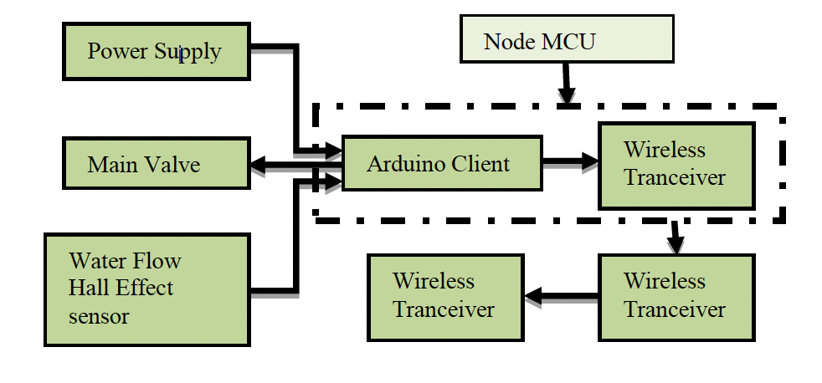

**Figure 2.1 Block diagram of project 01**

Project 02: Measurement and Control of water flow using IOT [6]

Research that was created for apartment or huge housing areas in city side was released by the Department of ECE at the NARASARAOPETA Engineering College in NARASARAOPET, India (522601). Text messages (SMS) are used to communicate water consumption information and limit status to the control station. This data is uploaded and shown on the OLED. In this, the MIT mobile app is being used to upload the water use information using the Bluetooth Module HC05. Water bills that need to be paid are uploaded to mobile devices, and alarms are delivered to the appropriate in charge. Using a mobile application, the in charge can even stop the water flow.

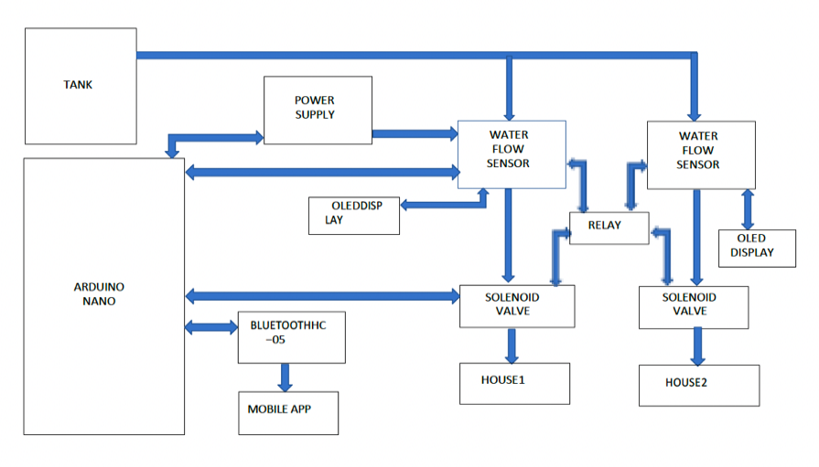

**Figure 3.2 Block diagram of project 02**

However, the previously mentioned research has its own benefits and drawbacks, and the method to use will rely on variables like cost, accuracy, and scalability. The first project is only concerned with comparing manual readings with sensor reading data in a timely manner and producing a final output that indicates whether the water consumption is accurate. After the comparison, users can get an idea and act regarding the water usage. The main disadvantage of this project is that the user is unable to monitor real-time data insights.

The second project also includes various important components, including reading, monitoring, integrated mobile interface, and water control management. LED screen function, however, the project's scope was extremely constrained, and this project is only appropriate for expanding cities and apartment complexes; the system's user features, and access is also severely restricted.

According to the study of Literature survey, our project has the solutions for major issues that we have identified and discussed. Our project includes Real time water Consumption Monitoring system with water flow Sensor, Digital Reading, and monitoring feature for Users in home using LED Display, Smart water controlling from anywhere anytime. Water leakage detection, Alerting system for Users via Mobile Application, Automated billing generation system through mobile application, Water Quality management feature, User location detection system using GPRS/GSM module, Efficient user management for Water Board administrators using web interface enabling the decision making with past consumption details.

# Chapter 3

## 3.1. Methodology

The smart water meter system is the best solution design for water consumption monitoring, management, and preservation. This project incorporating hardware devices, cloud technology, and user-friendly mobile app. This project we intend to provide water leakage detection, accurate real time data, measure water usage, monthly water bills and remote controlling valve for effective and efficient water usage.

**Hardware integration and components**

The project most important components such as the ESP8266 microcontroller, water flow sensor, TDS water conductivity sensor and RTC module. The ESP8266 is the brain of our project. It connects to the internet, reading data from sensors and communicates with cloud services and database after sending the mobile app to provide real time data and controlling. Using this flow sensor calculates flow rate, water unit and total water usage(liters). RTC module provides accurate track of time for the system [7]. This allows users to track water usage and quality specific time interval. These components accurately measure and record real time water usage. This means users can access up-to-date information about their water usage. This immediate awareness users to identify leading to more aware usage.

**Water quality monitoring**

Using water conductivity sensor users measure water quality and detect pollution [8]. This feature can make decisions to safeguard health and contribute to water management. This error-free monitoring authorizes users to understand water usage patterns and make and control decisions. If whether water is not fit for use, then the system sends notifications and alerts the user mobile phone.

**Interfaces and water controlling**

The mobile app is designed for both users and administrators. The interfaces allow users to view their water usage data in real time. This instant access ensures that users can response when raising water usage and make decisions quickly. With the solenoid valve, the most important function of this mobile interface is if water leakage detection users can automatically turn off the water meter from anywhere [9]. Water leak detection algorithms prevent water wastage. This function will send notifications and alerts to users of mobile phones. Quick detection helps users minimize water wastage and reduce cost.

**Device tracking and water leakage detection**

However, the administrators allow to view and track water meter anywhere using this GPRS/GSM module [10]. This function is thoughtful to find out users’ location. Also, admins can add unaccustomed users and devices in this system using separate interfaces.it will be useful to tracking devices and find whether authorized users. Water leak detection algorithms prevent water wastage. This function will send notifications and alerts to user mobile phones [10]. Quick detections help users minimize water wastage and reduce cost.

Eventually, the smart water meter system is about the next level of technology. It allows be understanding and control their water usage, encourages a sense of responsibility and ownership over this valuable resource. Our system is being developed for improving water conservation with modern technology to minimize the difficulties in the current system.

## 3.2. Block Diagram

# Chapter 4

## Testing & Evolution.

Developing a smart water meter and mobile app requires careful planning, testing and evaluation to ensure its effective and sustainability. Before the test, a proper study was done on the functionality. We are planning to test our project in four testing procedures, and we hope these four methods are important to successfully build this project.

Functionality testing involves verifying that mobile app system and devices to confirm that it performs its functions effectively and efficiently. This testing we hope to test whether the system’s functions and components operate as users expected to design specifications. It allows tasks such as checking user actions, input validations and system response. By assessing the system’s functionality, testing procedure ensures that it meets user’s requirements, operates reliably and delivers as user experience satisfy. This procedure we hope to test and verify that the smart water meter is correctly measuring and transmitting water usage properly and check if the display and mobile app accurately display real-time water usage data from water meter.

In the connectivity testing we hope to assess the seamless communication between the smart water meter and the mobile app. This testing verifies that the effectiveness of communication of NodeMCU (ESP8266), to ensure that the meter send water usage, water quality (TDS value) and location tracking to the cloud and database over the internet after that real-time data update the mobile app interfaces. This main objective of that confirms that the app can stable and proper connection to the water meter. Enabling real time and accurate data receiving.by connectivity testing, our projects members ensure that users can continuously monitor water usage through the mobile without any interruptions contributing to a reliable user-friendly experience.

In the data accuracy testing we hope to ultra-carefully verify the stability and correctness of the water usage data displayed on the mobile app and display. We compare the data presented on the app and display with the actual water usage recorded by the smart water meter to confirm that there are no hiding errors or disagreement. By doing accuracy testing, we ensure that users can depend on the apps and display information to make decisions about their water usage patterns. This contributes to trust in the water meter and system functions enhances the benefits of the smart water meter and mobile app.

Finally, in performance testing we hope to test assess worth of the app reactivity and efficiency in handling data receiving and display tasks. We plan to how to rapidly pick up the mobile app pickup and present real-time and historical water usage data from the meter, when exact to different networks conditions. By accessing data performance, we ensure that the app keeps up its usability and sensibility, allowing users to access error-free information without any delay.

## 4.2. Gantt chat

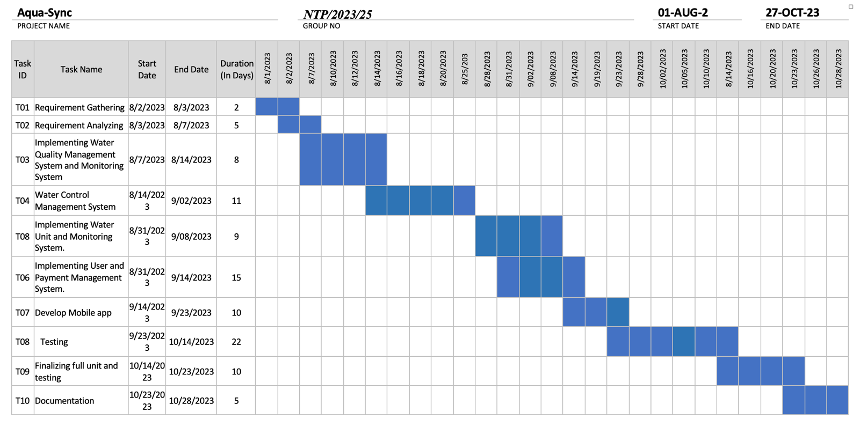

# Chapter 5

## 5.1. Conclusion

In this project, we want to design the overall architecture of smart water meter system. It realizes system management, remote meter reading and Data analysis. We have added various features. For instance, Leak Detection, Location tracking, Auto On/Off water meter and Automated Billing. This project’s ability to quickly detect leaks contributes to resource conservation. The initiative decreases labor for the Sri Lanka Water Board and assures timely invoicing by automating billing operations and providing leak detection. With Aqua sync app this by generating usage reports, Billing and provide real-time insights. This initiative not only modernizes monitoring but also conserves water through timely anomaly detection. This comprehensive approach not only benefits users but also water board. This system has high practical value in business optimization and production management.

# Bibliography

(n.d.). Retrieved from https://ecsxtal.com/what-is-a-real-time-clock-rtc/#:~:text=A%20real%20time%20clock%2C%20or,an%20embedded%20quartz%20crystal%20resonator.

(n.d.). Retrieved from https://riverwatchsolutions.com/sensors/conductivity#:~:text=Conductivity%20measurement%20can%20detect%20changes,aquatic%20ecosystems%20and%20human%20health.

A Amir, R. F. (2022). Smart water meter for automatic meter reading. *International Conference on Science in Engineering and Technology (ICoSiET 2020).*

A V Nageswararao, V. V. (2023). MEASUREMENT AND CONTROL OF WATER FLOW USING IOT. *Eur. Chem. Bull. 2023,12(Special Issue 4),11509-11513.*

Emmanuel Migabo, K. D. (2021). Design of an Energy Efficient LoRaWAN-Based Smart IoT Water Meter for African Municipalities. *International Conference on Electrical, Computer and Energy Technologies(ICECET), DOI: 10.1109/ICECET52533.2021.9698443.*

*Engineers Edge, LLC , Fluid Volumetric Flow Rate Equation". Engineers Edge*. (2016, 12 01). Retrieved from http://www.engineersedge.com/fluid_flow/volumeetric_flow_rate.htm

*engineersgarage*. (n.d.). Retrieved from https://www.engineersgarage.com/gsm-gprs-module-all-you-need-to-know/

hthfufu. (2023). *kjfjhjh.* khk: jjgdt.

M Suresh1, U. M. (2017). A Novel Smart Water-Meter based on IoT andSmartphone App for City Distribution Management. *DOI: 10.1109/TENCONSpring.2017.8070088.* Kerala.

*Omega*. (n.d.). Retrieved from https://www.omega.com/en-us/resources/valves-technical-principles

Prof. S.B. Idhate, T. M. (2015). IoT Based Smart Water Meters and Tap Leakage Detection. *International Journal of Science and Research(IJSR).*

# Bibliography

(n.d.). Retrieved from https://ecsxtal.com/what-is-a-real-time-clock-rtc/#:~:text=A%20real%20time%20clock%2C%20or,an%20embedded%20quartz%20crystal%20resonator.

(n.d.). Retrieved from https://riverwatchsolutions.com/sensors/conductivity#:~:text=Conductivity%20measurement%20can%20detect%20changes,aquatic%20ecosystems%20and%20human%20health.

A Amir, R. F. (2022). Smart water meter for automatic meter reading. *International Conference on Science in Engineering and Technology (ICoSiET 2020).*

A V Nageswararao, V. V. (2023). MEASUREMENT AND CONTROL OF WATER FLOW USING IOT. *Eur. Chem. Bull. 2023,12(Special Issue 4),11509-11513.*

Emmanuel Migabo, K. D. (2021). Design of an Energy Efficient LoRaWAN-Based Smart IoT Water Meter for African Municipalities. *International Conference on Electrical, Computer and Energy Technologies(ICECET), DOI: 10.1109/ICECET52533.2021.9698443.*

*Engineers Edge, LLC , Fluid Volumetric Flow Rate Equation". Engineers Edge*. (2016, 12 01). Retrieved from http://www.engineersedge.com/fluid_flow/volumeetric_flow_rate.htm

*engineersgarage*. (n.d.). Retrieved from https://www.engineersgarage.com/gsm-gprs-module-all-you-need-to-know/

hthfufu. (2023). *kjfjhjh.* khk: jjgdt.

M Suresh1, U. M. (2017). A Novel Smart Water-Meter based on IoT andSmartphone App for City Distribution Management. *DOI: 10.1109/TENCONSpring.2017.8070088.* Kerala.

*Omega*. (n.d.). Retrieved from https://www.omega.com/en-us/resources/valves-technical-principles

Prof. S.B. Idhate, T. M. (2015). IoT Based Smart Water Meters and Tap Leakage Detection. *International Journal of Science and Research(IJSR).*

# Refe (hthfufu, 2023)rences

|  |  |
| --- | --- |
| [1] | U. M. J. C. M Suresh1, "A Novel Smart Water-Meter based on IoT andSmartphone App for City Distribution Management," in *DOI: 10.1109/TENCONSpring.2017.8070088*, Kerala, 2017. |
| [2] | K. D. A. K. Emmanuel Migabo, "Design of an Energy Efficient LoRaWAN-Based Smart IoT Water Meter for African Municipalities," in *International Conference on Electrical, Computer and Energy Technologies(ICECET), DOI: 10.1109/ICECET52533.2021.9698443*, 2021. |
| [3] | T. M. S. K. S. K. Prof. S.B. Idhate, "IoT Based Smart Water Meters and Tap Leakage Detection," in *International Journal of Science and Research(IJSR)*, 2015. |
| [4] | "Engineers Edge, LLC , Fluid Volumetric Flow Rate Equation". Engineers Edge," 01 12 2016. [Online]. Available: http://www.engineersedge.com/fluid_flow/volumeetric_flow_rate.htm. |
| [5] | R. F. Y. A. A Amir, "Smart water meter for automatic meter reading," in *International Conference on Science in Engineering and Technology (ICoSiET 2020)*, 2022. |
| [6] | V. V. R. ,. Y. J. R. A V Nageswararao, "MEASUREMENT AND CONTROL OF WATER FLOW USING IOT," in *Eur. Chem. Bull. 2023,12(Special Issue 4),11509-11513*, 2023. |
| [7] | [Online]. Available: https://ecsxtal.com/what-is-a-real-time-clock-rtc/#:~:text=A%20real%20time%20clock%2C%20or,an%20embedded%20quartz%20crystal%20resonator.. |
| [8] | [Online]. Available: https://riverwatchsolutions.com/sensors/conductivity#:~:text=Conductivity%20measurement%20can%20detect%20changes,aquatic%20ecosystems%20and%20human%20health.. |
| [9] | "Omega," [Online]. Available: https://www.omega.com/en-us/resources/valves-technical-principles. |
| [10] | "engineersgarage," [Online]. Available: https://www.engineersgarage.com/gsm-gprs-module-all-you-need-to-know/. |

|  |  |
| --- | --- |
| Functions | Facilities |
| Sujath – Quality Management Engineer | |
| Water Quality Management system  Use of analog TDS Water Conductivity sensor checks the TDS level of water. And monitoring the PH level. Display this on the LCD Display and the Aqua-Sync App. If the water is not in good condition send an alert SMS to customer use of GSM module. Create App interface to the water quality management and connect with database. | This needed the TDS water conductivity sensor, LCD Display. And high-performance computer to develop app & code GSM module. Laboratory help to get accurate TDS level. |
| Ashik – Project Manager & Mechanical Engineer | |
| Water Control Management System  Implement the circuit and program the solenoid valve to control the water flow using and on/off the water flow. Write algorithm to detect water leakage and send alert SMS. Develop the interface to on/off Button. And get Realtime date & time to the display thought the RTC Module. Connect the power supply to the physical product. | Needed Solenoid valve, RTC module to ensure accurate time and date. High  Strength signal Internet connection to transfer leakage data to database and notify SMS. Backup power supply. |
| Tharindu Lakshan – Embedded Engineer | |
| Water Unit Management  Implement the water flow sensor with microcontroller to get the water flow rate & water unit used. And write the program to calculate the bill amount. Implement the Display dashboard. Develop the database with IOT cloud to store water data. And design the app interface to show the Water flow sensor details. And the interface to set water usage limit. | Needs water flow sensor. high-performance computer to write Arduino program. High Strength signal Internet connection connect with IOT cloud database. Sri Lanka Water board billing calculation system. |
| Shanaka – Software Developer / UI UX Designer | |
| User location, billing History management  Implement the GSM module to track the device location and design the app interface to that. And set the SMS notification system to send bill amount use of GPRS/GSM module. Create the billing & payment history management interface to the Aqua-sync app. And the admin & login interface. Analysis of the data of water consumption use of machine learning. | High-performance computer to develop app. With java script knowledge to it.  Ide IntelliJ software access.  GPRS Module with backup database access. Machine learning to analysis. |

# Appendices

## Personal & Facilities

## Budget

|  |  |  |  |
| --- | --- | --- | --- |
| NO | Items | Unit Price | Total Amount |
| 01 | Microcontroller | 1250.00 | 1250.00 |
| 02 | Flow Sensor | 1390.00 | 1390.00 |
| 03 | RTC Module | 390.00 | 390.00 |
| 04 | GSM Module | 3500.00 | 3500.00 |
| 05 | 3D Printing | 4500.00 | 4500.00 |
| 06 | Display | 1200.00 | 1200.00 |
| 07 | Solenoid Valve | 1150.00 | 1150.00 |
| 08 | 12v Battery | 1190.00 | 1190.00 |
| 09 | Relay | 260.00 | 260.00 |
| 10 | TDS Water Conductivity Sensor | 4390.00 | 4390.00 |
|  | **TOTAL** |  | **19220.00** |